EENG 385 - Electronic Devices and Circuits

Lab 2 – Schmitt Trigger Relaxation oscillator

Lab Just Solutions

# Analysis Schmitt Trigger Relaxation Oscillator

1. Assume Vout = 9V, what is the voltage at the non-inverting input of the op amp? Call this voltage Vhigh. Hint, ignore the inverting input, put R4 and R8 in parallel and then use voltage divider.

**R4 in parallel with R8 is equivalent to 33k*15k/(33k+15k) = 10.3k**

**So Vhigh = 9V*33k/(33k + 10.3k) = 6.86V**

1. Assume Vout = 0V, what is the voltage at the non-inverting input of the op amp? Call this voltage Vlow. Hint, ignore the inverting input, put R4 and R6 in parallel and then use voltage divider.

**R4 in parallel with R6 is equivalent to 33k*15k/(33k+15k) = 10.3k**

**So Vlow = 9V*10.3k/(33k + 10.3k) = 2.14V**

1. Imagine Vin is at 0V, what is Vout? Hint, the voltage on the non-inverting input of the op amp is at least Vlow.

**If Vin = V- = 0V and V+ >= Vlow = 2.14V then V- < V+ so Vout = 9V.**

1. Imagine increasing Vin from 0V to just below Vhigh, what is Vout? Hint, use Vout from the Q3 (you are starting at 0V) to determine the value of non-inverting op amp input from Q1.

**If Vin = V- and V+ = Vhigh = 6.86V then V- < V+ so Vout = 9V.**

1. Imagine Vin continues to increase and goes just above Vhigh, what is Vout?

**If Vin = V- > V+ = Vhigh then Vout = 0V.**

1. Imagine Vin is at 9V, what is Vout? Hint, the voltage on the non-inverting input of the op amp is at least Vhigh.

**If Vin = V- = 9V and V+ <= Vhigh = 6.86V then V- > V+ so Vout = 0V.**

1. Imagine decreasing Vin from 9V to just above Vlow, what is Vout? Hint, use Vout from the Q6 (you are starting at 9V) to determine the value of non-inverting op amp input from Q2.

**If Vin = V- and V+ = Vlow = 2.14V then V- > V+ so Vout = 0V.**

1. Imagine Vin continues to decrease and goes just below Vlow, what is Vout?

**If Vin = V- < V+ = Vlow then Vout = 9V.**

1. Use this information to draw Vin vs. Vout hysteresis diagram similar to Figure 2. Label the Vin axis with the voltage values for Vlow and Vout you found in Q1 and Q2.

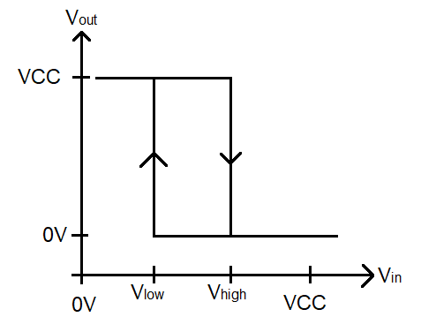

1. Assume Vout = 9V. In this case, there is a path for electrical flow from Vout through R4, through the (forward biased) diode D2, through capacitor C1 to ground. Diode D1 is reverse biased so eliminates the 47k resistor from the circuit. What is the time constant for this charging? Hint, you can replace the forward biased diode D2 with a wire.

**Time constant = RC = 3.3kΩ * 0.1uF = 0.33ms**

1. Use this time constant to write an equation describing the voltage on capacitor C1.
$$v\left(t\right)=9V(1-e^{-\frac{t}{0.33ms}})$$

2. Compute the time required for capacitor C1 to charge from Vlow to Vhigh
   * Set the equation you derived in Q11 equal to Vhigh and solve for t. Represent your answer in microseconds and round to the nearest integer.
 $$V_{t}\left(t\right)=6.86= 9{(1-e}^{-\frac{t}{0.33ms}})= 470us$$  * Set the equation you derived in Q11 equal to Vlow and solve for t. Represent your answer in microseconds and round to the nearest integer.
 $$V_{t}\left(t\right)=2.14= 9\left(1-e^{-\frac{t}{0.33ms}}\right)=90us$$  * To derive the time to charge C1 from Vlow to Vhigh subtract the time to get to Vhigh from the time to get to Vlow.

**470us – 90us = 380us**

1. Assume Vout = 0V. In this case, there is a path for electrical flow from the charged plate of the capacitor C1 through the (forward biased) diode D1, through resistor R5 to Vout = 0V. Diode D2 is reverse biased so eliminates the 3.3k resistor from the circuit. What is the time constant for this charging? Hint, you can replace the forward biased diode D1 with a wire.

**Time constant = RC = 47kΩ * 0.1uF = 4.7ms**

1. Use this time constant to write an equation describing the voltage on capacitor C1.
$$v\left(t\right)=9Ve^{-\frac{t}{4.7ms}}$$

2. Compute the time required for the capacitor C1 to discharge from Vhigh to Vlow as follows.
   * Set the Vt(t) equation equal to Vhigh and solve for t. This is the time to discharge from 9V to Vhigh. Represent your answer in milliseconds and round to three significant figures.
 $$V_{t}\left(t\right)=6.86= 9e^{-\frac{t}{4.7ms}}=1.28ms$$  * Set the Vt(t) equation equal to Vlow and solve for t. This is the time to discharge from 9V to Vlow. Represent your answer in milliseconds and round to three significant figures.
 $$V_{t}\left(t\right)=2.14= 9e^{-\frac{t}{4.7ms}}=6.75ms$$  * To derive the time to discharge C1 from Vhigh to Vlow, subtract the time to get to Vhigh from the time to get to Vlow.

**6.75ms – 1.28ms = 5.47ms**

1. When Vout = 9V then the capacitor C1 is **charging**/discharging from Vlow to Vhigh. It takes this capacitor 380us to go from Vlow to Vhigh. When the **charging**/discharging capacitor’s voltage exceeds Vlow/**Vhigh** then Vout = 0V. When Vout = 0V the capacitor will start to charge/**discharge**.
2. When Vout = 0V then the capacitor C1 is charging/**discharging** from Vhigh to Vlow. It takes this capacitor 5.47ms to go from Vhigh to Vlow. When the charging/**discharging** capacitor’s voltage drops below **Vlow**/Vhigh then Vout = 9V. When Vout = 9V the capacitor will start to **charge**/discharge.

# Simulation Schmitt Trigger Relaxation Oscillator

Include one wavelength of the output and capacitor voltage in your answers. You can use the export option in the main menu to output a png file.

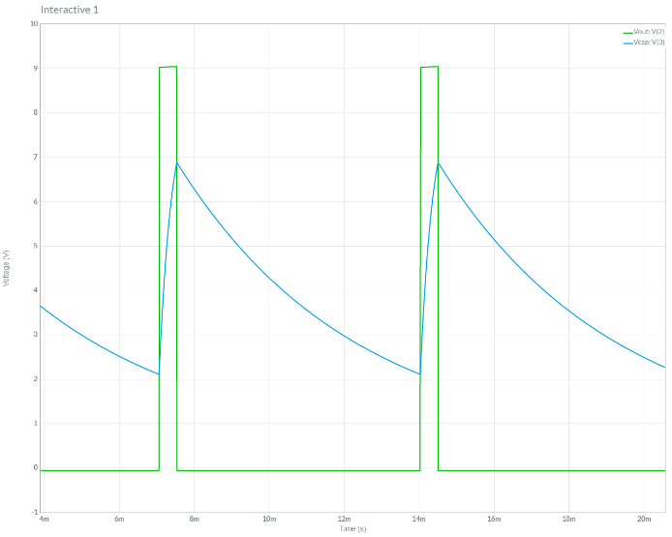

**Assemble Schmitt Trigger Relaxation Oscillator**

Table 3: Match the schematic symbol with the corresponding part.

|  |  |  |  |
| --- | --- | --- | --- |
| Schematic Symbol |  | Match | Physical Part |
| A |  | D | Mono-Kap H5 |
| B |  | C | CF 4-7k |
| C |  | E |  |
| D |  | B | DO-35 |
| E |  | A |  |

After you get everything setup, screen shot the Vout and Vcap waveforms and include in your lab report.

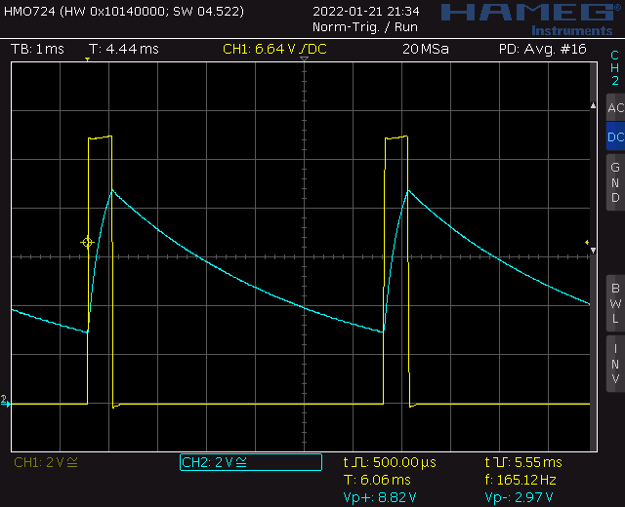

Note this oscilloscope trace was captures on a Rhode&Schwarz HMO724 using a 12V supply for the BJT curve tracer.

* + Press the “Default Setup’” button to undo any weird configuration that the last user may have left the oscilloscope in.
  + Check that solder connections by trying to wiggle each component. There should be no visible movement.
  + Check that all pins of the TLC274 are firmly engaged into the IC socket.

# Turn in:

Make a record of your response to numbered items below and turn them in a single copy as your team’s solution on Canvas using the instructions posted there. Include the names of both team members at the top of your solutions. Use complete English sentences to introduce what each of the following listed items (below) is and how it was derived.

**Analysis Schmitt Trigger Relaxation Oscillator**

Steps 1 – 17

Fill in Analysis columns of Table 4.

Fill in Analysis columns of Table 5.

**Simulation Schmitt Trigger Relaxation Oscillator**

Schematic (use Export -> Schematic Image)

Timing diagram (use Export -> Grapher Image)

Fill in Simulation columns of Table 4.

Fill in Simulation columns of Table 5.

**Assemble Schmitt Trigger Relaxation Oscillator**

Complete Table 3

Fill in Assemble columns of Table 4.

Fill in Assemble columns of Table 5.

**Analysis**

Complete the following table using the information you found in the following sections. Represent your answer in 2 or 3 significant figures using the units given in the quantity column.

Table 4: Summary of Vout behavior in the Schmitt Trigger Relaxation Oscillator.

|  |  |  |  |
| --- | --- | --- | --- |
| Quantity | Analysis | Simulation | Assemble |
| Time high (us) | 0.38ms | 0.47ms | 0.50ms |
| Time low (us) | 5.47ms | 6.48ms | 5.6ms |
| Period (us) | 5.85ms | 6.95ms | 6.1ms |
| Frequency (kHz) | 171Hz | 144Hz | 164Hz |
| Duty Cycle | 6.5% | 6.8% | 8.2% |

Table 5: Summary of the 0.1uF capacitor voltage in the Schmitt Trigger Relaxation Oscillator.

|  |  |  |  |
| --- | --- | --- | --- |
| Quantity | Analysis | Simulation | Assemble |
| Vhigh | 6.86V | 6.89V | 6.6V |
| Vlow | 2.14V | 2.11V | 2.2V |